

**INSTITUTE FOR ADVANCED COMPUTING AND**

**SOFTWARE DEVELOPMENT AKURDI, PUNE**

**“Delight Kitchen”**

PG-DAC August 2024

*Submitted by:*

**Group No: 17**

**Roll No: Name:**

248028 Gaurav Sapkale

248089 Shivam Tripathi

**Mrs. Geeta Darunte Mr. Rohit Puranik**

Project Guide Center Coordinator

**ABSTRACT**

This project is a web-based Restaurant System for a specific restaurant. The project objective is to deliver restaurant management applications into web platforms.

This project is an attempt to provide the advantages of using restaurant management applications to a specific restaurant in the real world which intends to manage their restaurant functionality online via using an application. It helps in reducing human effort by maintaining the workflow of a restaurant in online mode, where each staff person working in the restaurant could do their job role efficiently. This system can be implemented to specific restaurants which wish to operate their restaurant functionalities in the online mode via application (specific to particular restaurant).

If the restaurant is using an online system to manage its functionalities, then much of human efforts will be reduced and efficient services will be made available to the visited restaurant. If a visiting customer is well satisfied with the service, positive feedback will be given by his side as a result the rating of a restaurant will increase and in future more and more customers will pay a visit.

**ACKNOWLEDGEMENT**

We take this occasion to thank God, almighty for blessing us with his grace and taking our endeavour to a successful culmination. I extend my sincere and Heartfelt thanks to our esteemed guide, **Mrs. Geeta Darunte** for providing me with the right guidance and advice at the crucial juncture and for showing me the right way. I extend my sincere thanks to our respected Center Co-Ordinator **Mr. Rohit Puranik**, for allowing us to use the facilities available. I would like to

thank the other faculty members also, at this occasion. Last but not the least, I would like to thank my friends and family for the support and encouragement they have given me during the course of our work.

**Gaurav Sapkale** (240841220053) **Shivam Tripathi** (240841220171)

**Table of Contents**

|  |  |  |
| --- | --- | --- |
| **Sr.No** | **Description** | **Page No.** |
| 1 | Introduction | 1 |
| 2 | SRS | 4 |
| 3 | Diagrams | 7 |
| 3.1 | ER Diagram | 7 |
| 3.2 | Use Case Diagram | 8 |
| 3.3 | Data Flow Diagram | 9 |
| 3.4 | Activity Diagram | 10 |
| 3.5 | Class Diagram | 12 |
| 3.6 | Sequence Diagram | 13 |
| 4 | Database Design | 14 |
| 5 | Snapshots | 16 |
| 6 | Conclusion | 32 |
| 7 | References | 33 |

1. **Introduction**

This project is a web-based Restaurant System for a specific existing restaurant. It presents a detailed explanation of the objectives, features, user interface and application of Restaurant Management System (RMS) in real life. It will also describe how the system will perform and under which it must operate. The Restaurant System allows the restaurant’s staff along with manager to log in the application where they all can track their work and services that need to be delivered to the visited customer according to their respective job roles. This project attempts to provide the advantages of online restaurant management by reducing human effort and time.

**Document Purpose**

The aim of this document is to explain the functionality of the project developed for Restaurant Management System (RMS). This document provides the flow about how the services are being managed and provided to a customer in an efficient manner whenever he makes a visit to a restaurant.

**Product Scope**

This system will help to manage the restaurant business systematically. In this management system, we have designed a web application that can be used by the Manager along with the staff of that restaurant to manage the food orders given by the customers, so that the manager of that restaurant can monitor and ensure the smooth conduct of the whole system.

This will lead to serving food faster and ultimately a better kitchen place to revisit it again. In addition to this, the system is capable of hiring different job roles required for a restaurant, the required information about staff will be saved in the system which can be only accessed by the system admin.

**Aim & Objectives**

Specific goals are: -

* To produce a web-based system that allows the admin to manage whole restaurant functionalities efficiently.
* To ease different staff member to service their respective work and functionalities.
* The main aim of this web application is to reduce human efforts and time by providing multiple features in an online mode that so restaurant owner can run their business smoothly.

**Users and Characteristics**

In our application we have mainly 4 users, which are the staff members working in that particular restaurant having specific job role.

* **There are various role in a restaurant**
* Manager
* Chef
* Cashier
* Waiter
* **Functionalities of different roles:**
* **Manager**

➢ Add/Manage food Category(availability)

➢ Add/Manage food items under available Category

➢ Add/Manage Tables

➢ Add/Manage Staffs

➢ Add/Manage Orders

➢ Billing of Orders

➢ Can change his profiles details

●  **Chef**

➢ Add/Manage food Category(availability)

➢ Add/Manage food items under available Category

➢ Manage Orders

➢ Can change his profiles details

**● Cashier**

➢ Billing of Orders

➢ Can view history of previous orders

➢ Can change his profiles details

**● Waiter**

➢ Add/Manage Orders

➢ Can change his profiles details

1. **System Requirement Specifications**

**Operating Environment**

* **Server-Side Configuration**

**Processor:** Intel® i5 processor series

**HDD:** Minimum 250 GB Disk Space

**RAM:** Minimum 4 GB

**OS:** Windows 8, Linux

**Database:** MySQL

**Client-Side Configuration**

**Processor:** Intel® i5 processor series

**HDD:** Minimum 250 GB Disk Space

**RAM:** Minimum 4 GB

**OS:** Windows 8, Linux

**Software Interfaces:**

Software configuration for back-end Services:

* Java EE
* Spring Boot, JPA, Razor Pay, Spring Authentication
* MySQL
* STS 4.x.x

**Software configuration for front-end Services:**

* ReactJS, Redux
* HTML, CSS, JS
* Bootstrap

**Design and Implementation Constraints**

* The application will use Ajax, JavaScript, jQuery and CSS as main web technologies.
* HTTP and FTP protocols are used as communication protocols. FTP is used to upload the web application in live domain and the client can access it via HTTP protocol.
* Several types of validations make this web application a secured one and SQL Injections can also be prevented.
* Since Restaurant System is a web-based application, internet connection must be established.
* The Society Management System will be used on PCs and will function via internet or intranet in any web browser.

**External Interface Requirements**

* **User Interfaces**
* All the users will see the same page when they enter in this website. This page asks the users a username and a password.
* After being authenticated by correct username and password, user will be redirect to their corresponding profile where they can do various activities.
* The user interface will be simple and consistence, using terminology commonly understood by intended users of the system. The system will have simple interface, consistence with standard interface, to eliminate need for user training of infrequent users.

5

* **Hardware Interfaces**
* No extra hardware interfaces are needed.
* The system will use the standard hardware and data communication resources.
* This includes, but not limited to, general network connection at the server/hosting site, network server and network management tools.
* **Application Interfaces**

**OS:** Windows 8, Linux

**Web Browser:**

The system is a web-based application; clients need a modern web browser such as Mozilla Firebox, Internet Explorer, Opera, and Chrome. The computer must have an Internet connection in order to be able to access the system.

1. 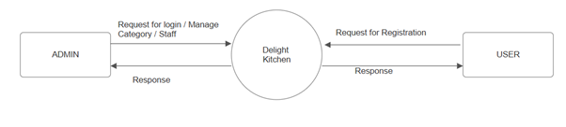**Diagrams**

**Zero Level Diagram**

* 1. **ER Diagram**

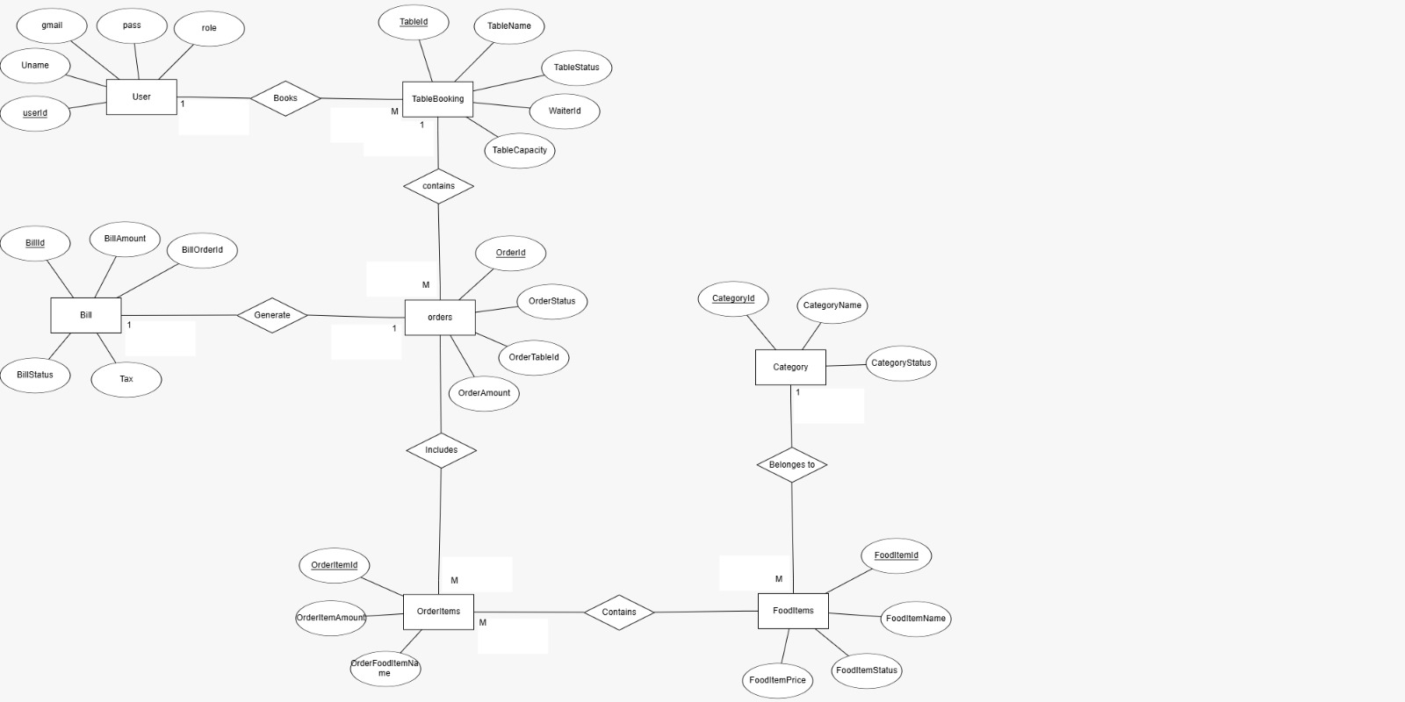

**Figure 1: ER Diagram**

**3.2 Use Case Diagram**

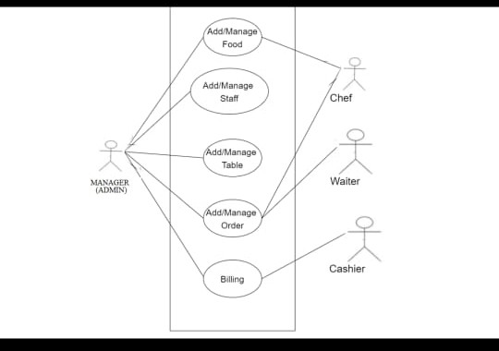

**Figure 2– Use Case Diagram**

**3.3 Data Flow Diagram**

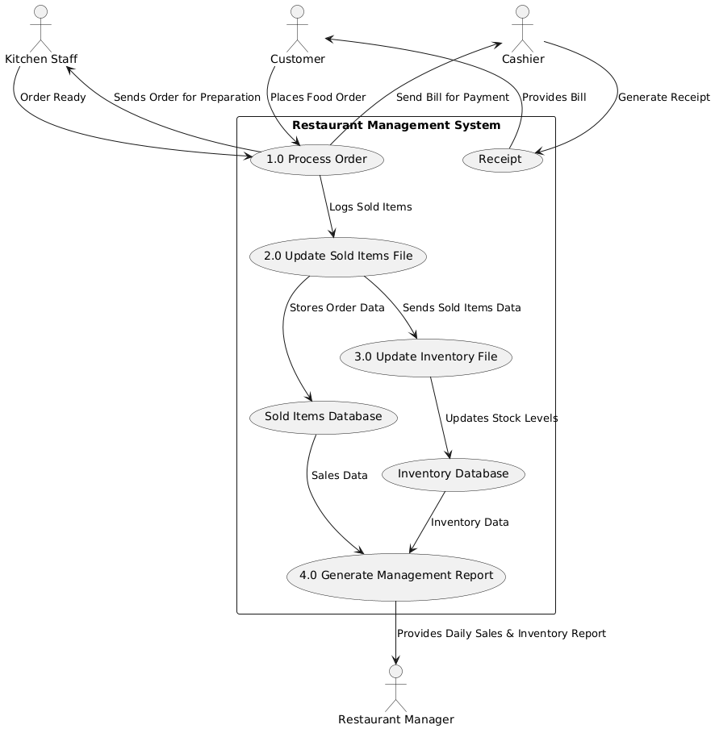

**Figure 4: 1 Level Diagram**

* 1. **Activity Diagram**

**Admin Activity Diagram**

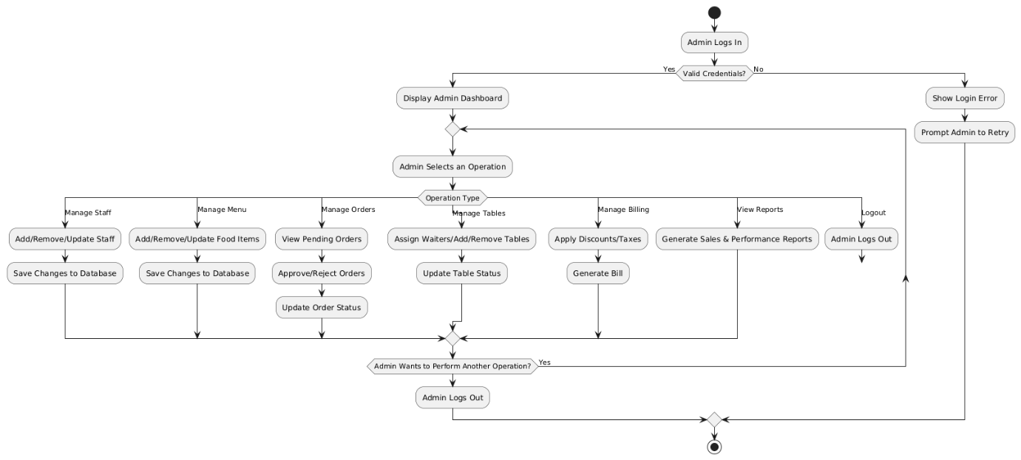

**Chef Activity Diagram**

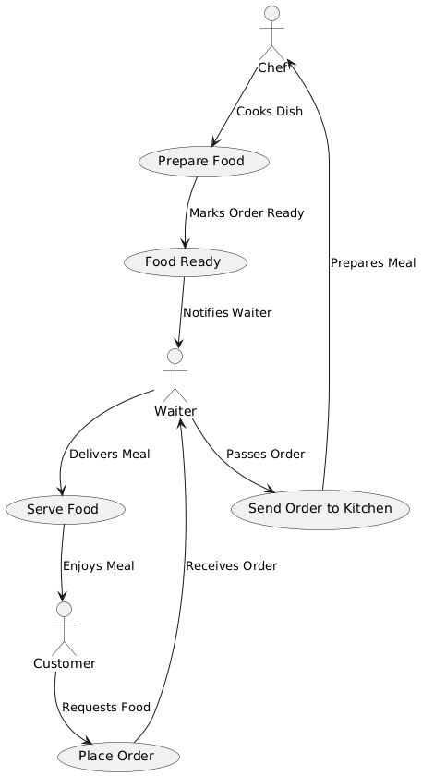

**3.5 Class Diagram**

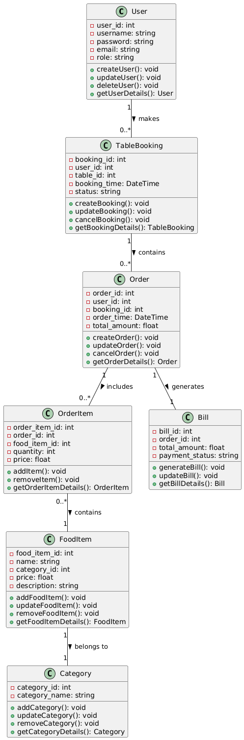

**3.6 Sequence Diagram**

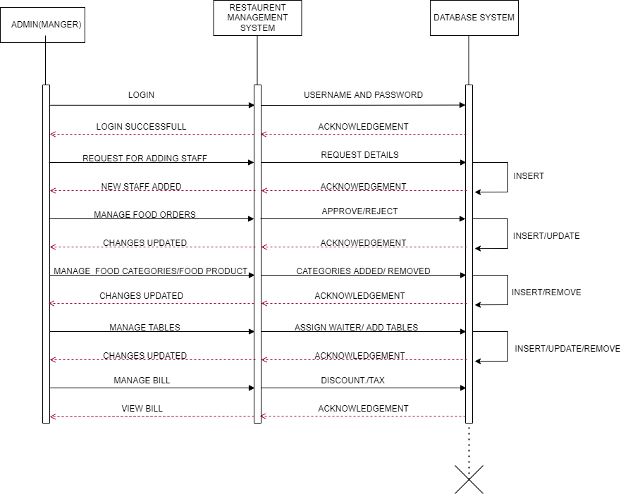

**Figure 8: Sequence Diagram for Admin**

**4. Database Design**

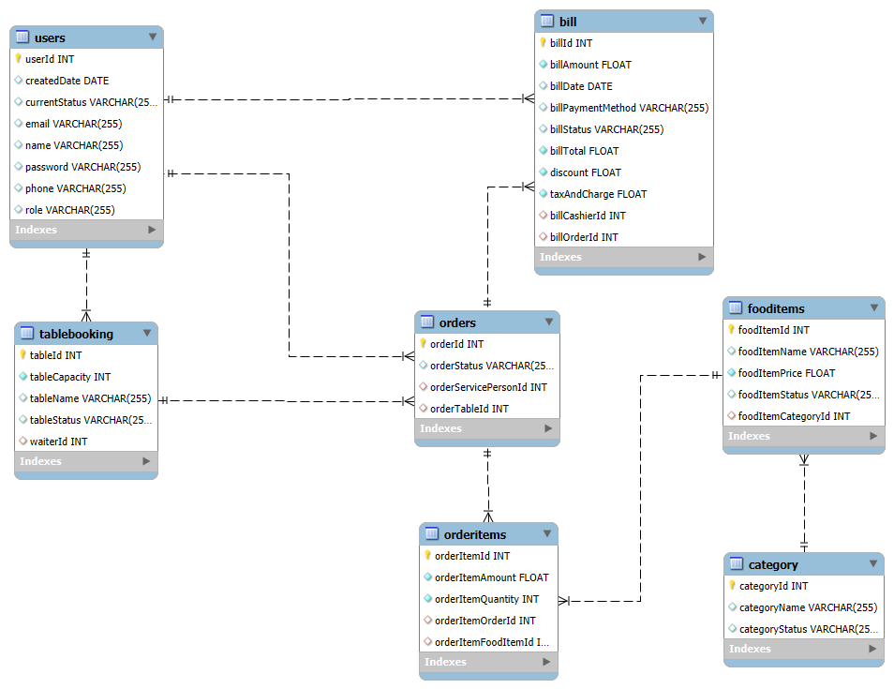

**User:**

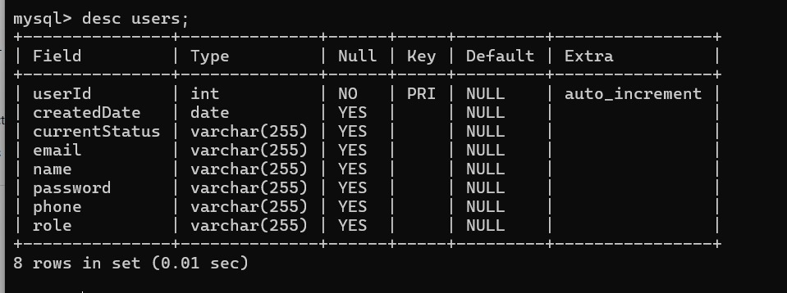

**Table Booking:**

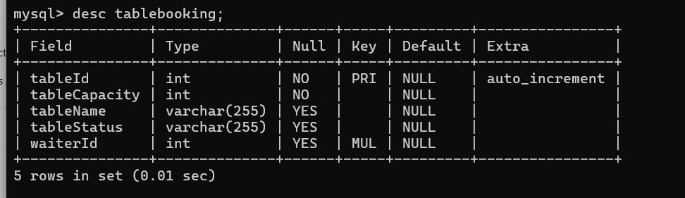

**Orders:**

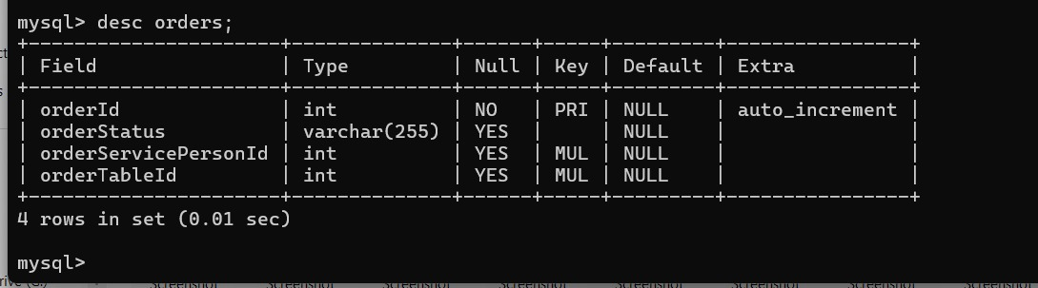

**Bills:**

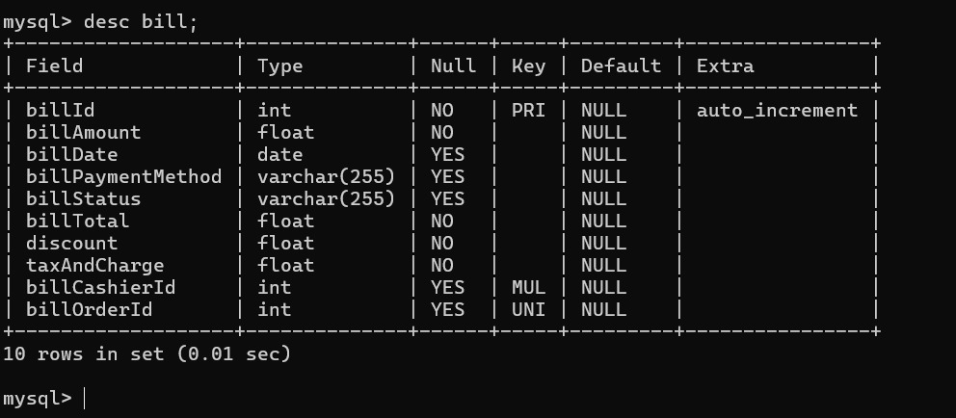

**OrderItems:**

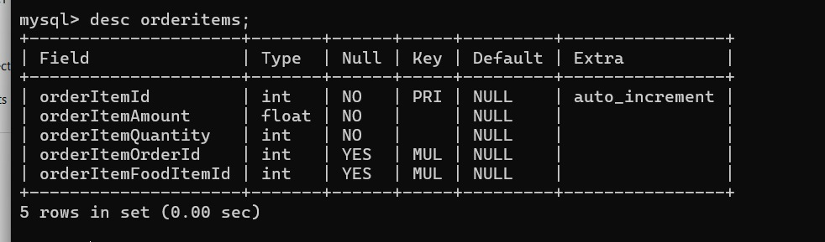

**FoodItems:**

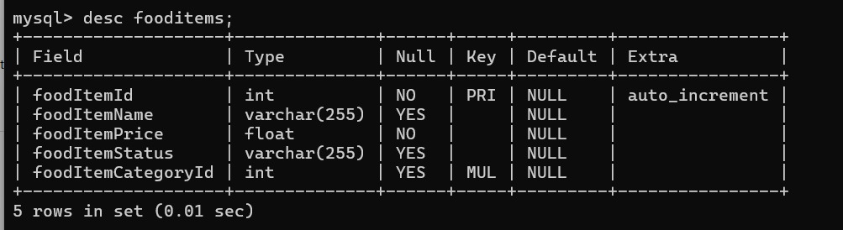

**Category:**

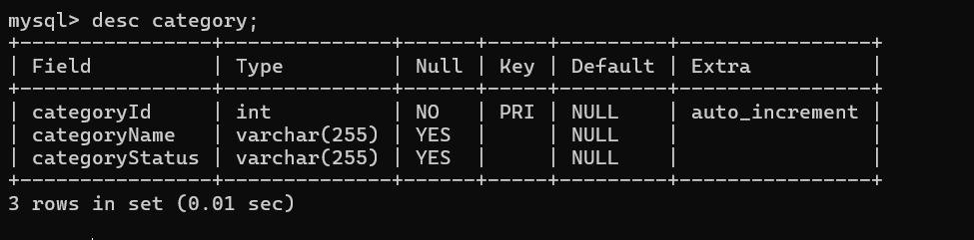

1. **Snapshots**

**LOGIN SECTION FOR MANAGER**

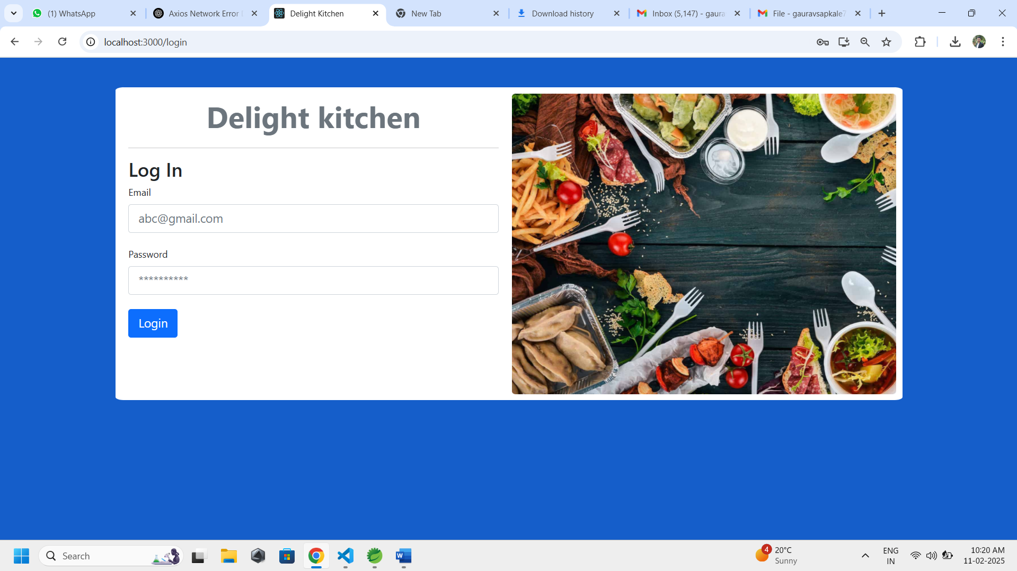

**DASHBOARD OF MANAGER**

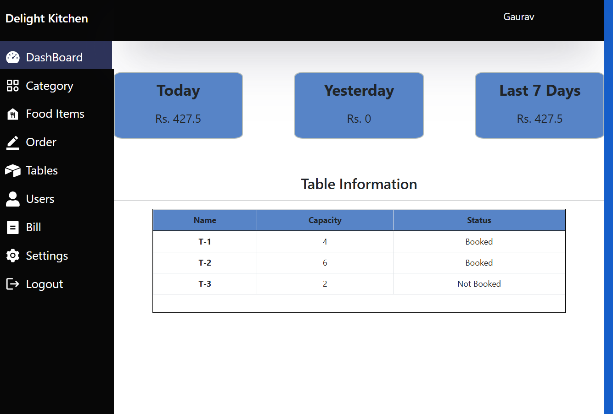

**SCREEN OF MANAGER (GAURAV) OF HUNGRY FOODS RESTAURANT**

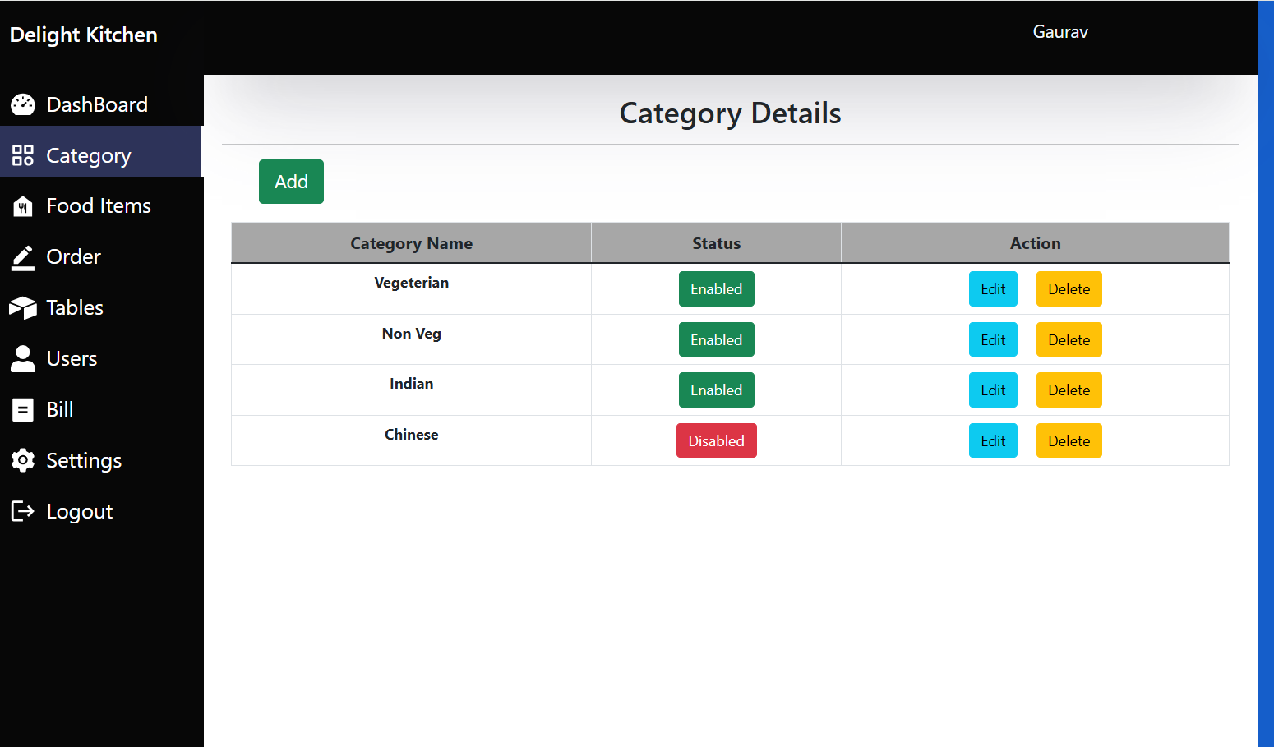

**STAFF OF RESTAURANT(USERS) WHO CAN ACCESS THE APPLICATION**

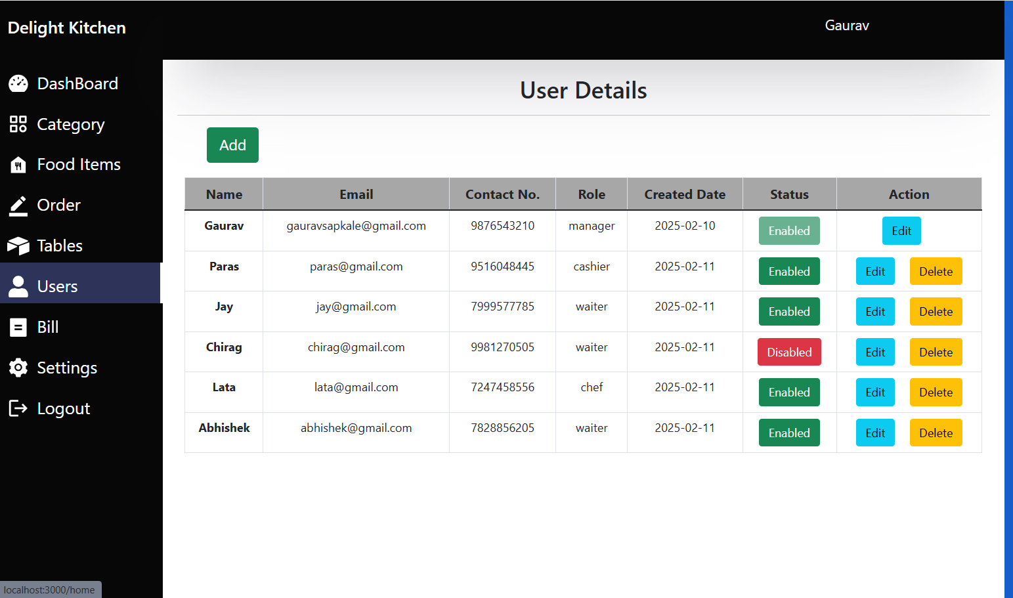

**ADDITION OF NEW STAFF MEMBER(Waiter) BY MANAGER**

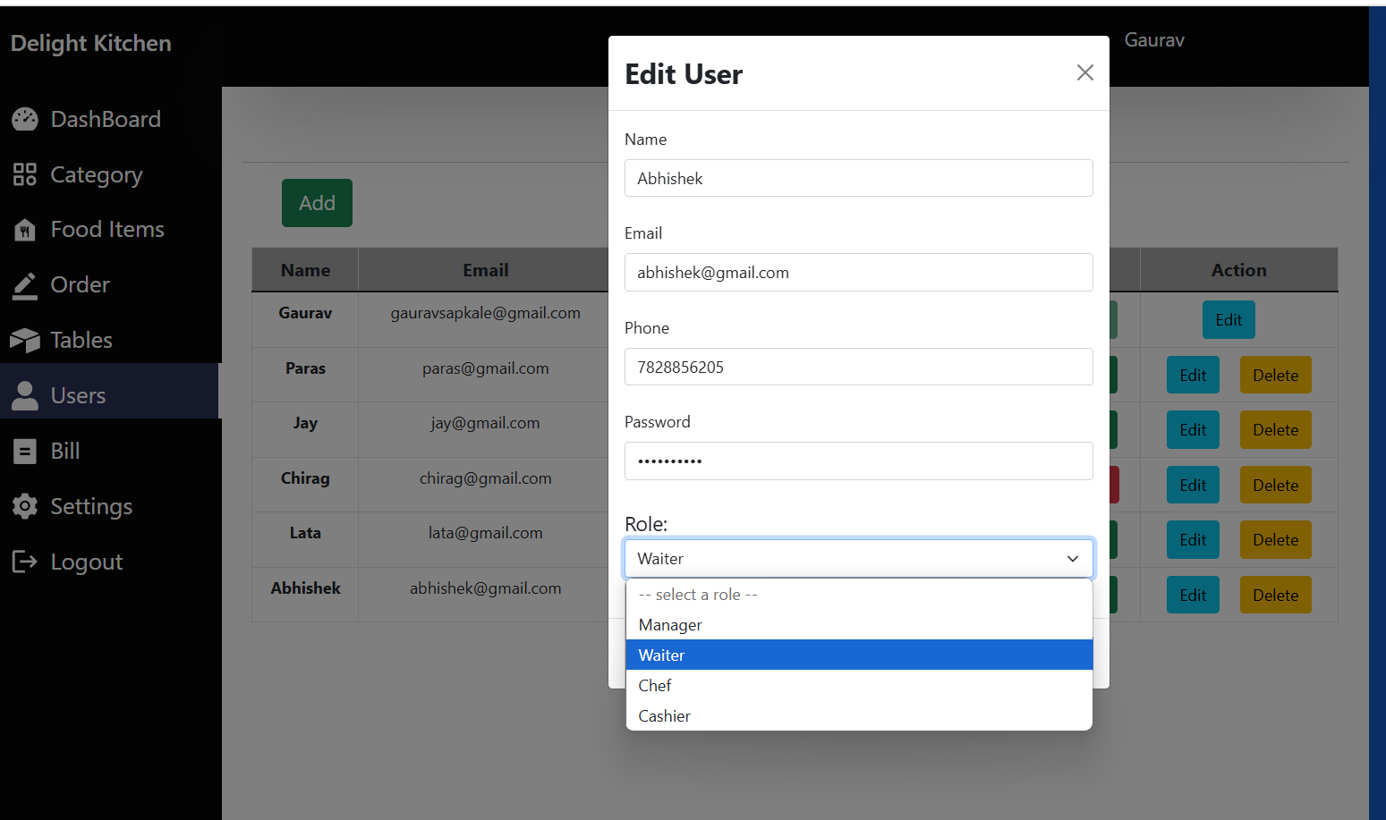

**ADDED STAFF MEMBER (waiter) DISPLAYED UNDER USER**

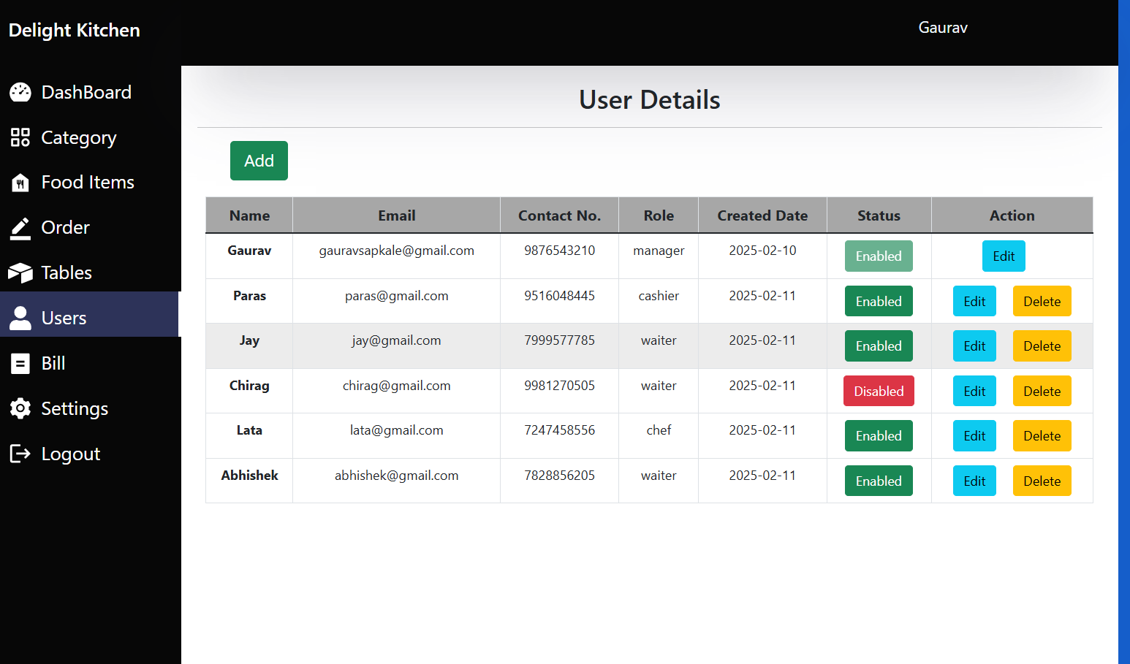

**MANAGER CAN TEMPERORY DISABLED/ENABLED STAFF**

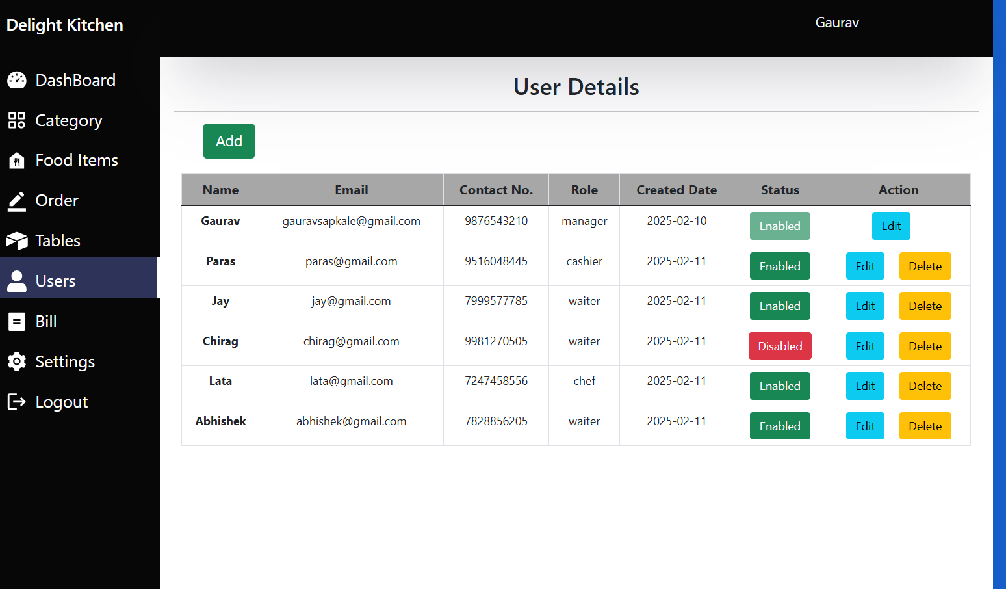

**DETAILS OF STAFF (CASHIER) UPDATED AND DELETED BY MANAGER**

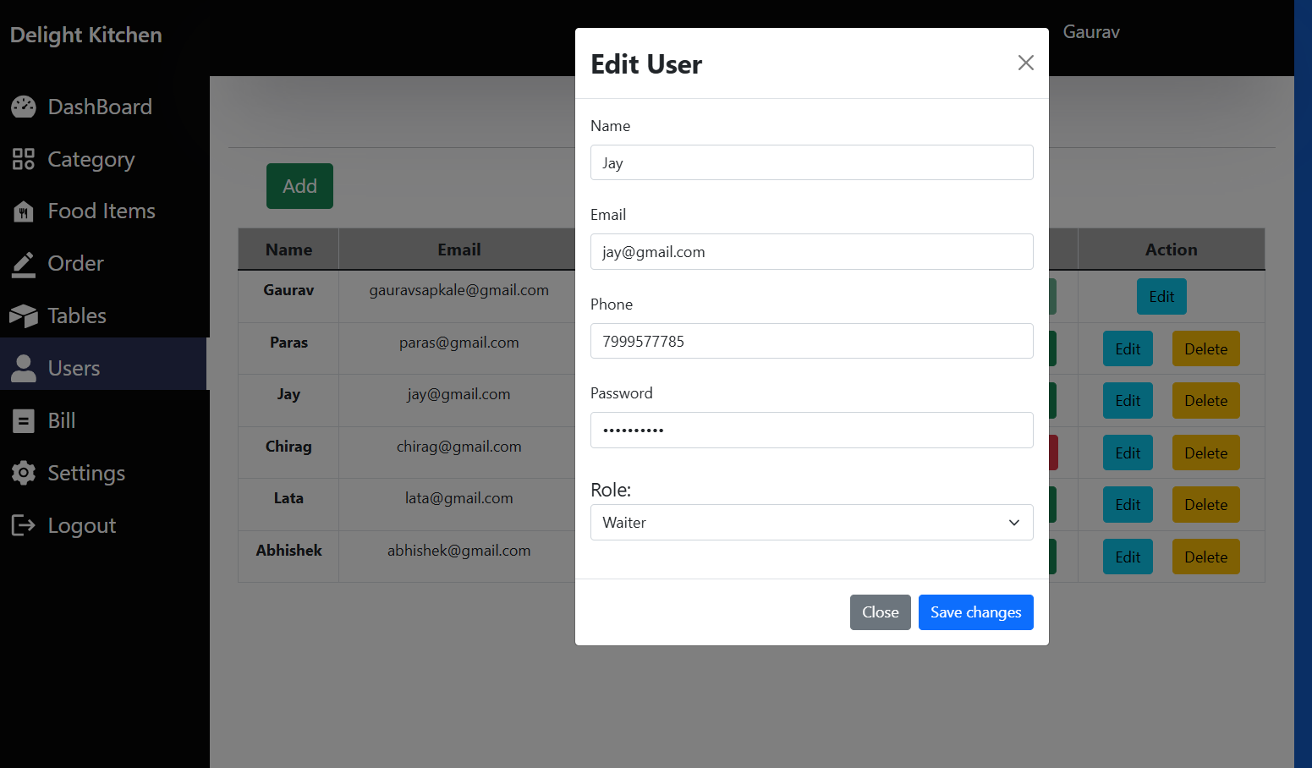

**MANAGER CAN UPDATE HIS PASSWORD OR DETAILS FROM SETTINGS SECTION**

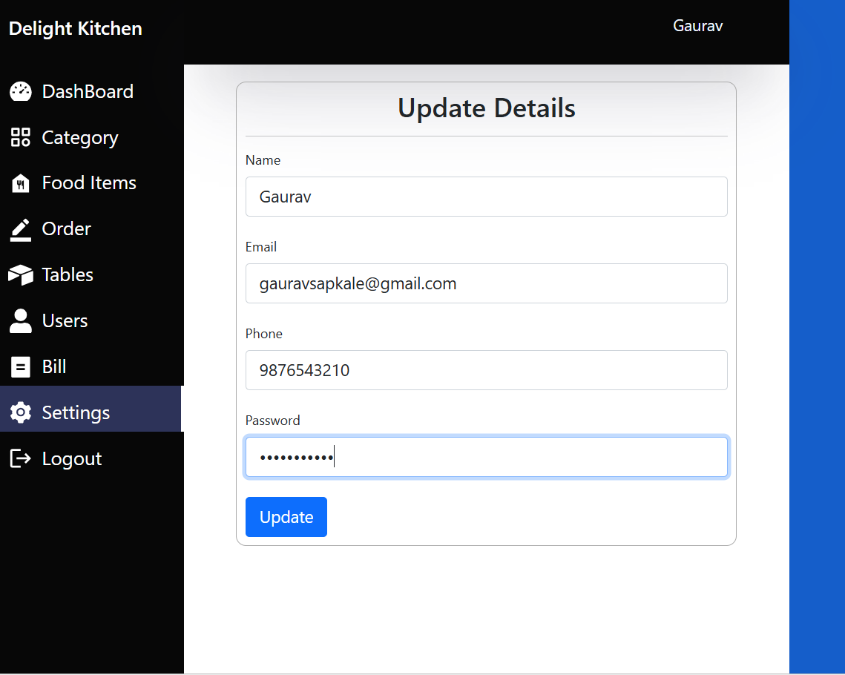

**NOW ENTERED NEW CREDENTIAL TO LOG IN AS MANAGER**

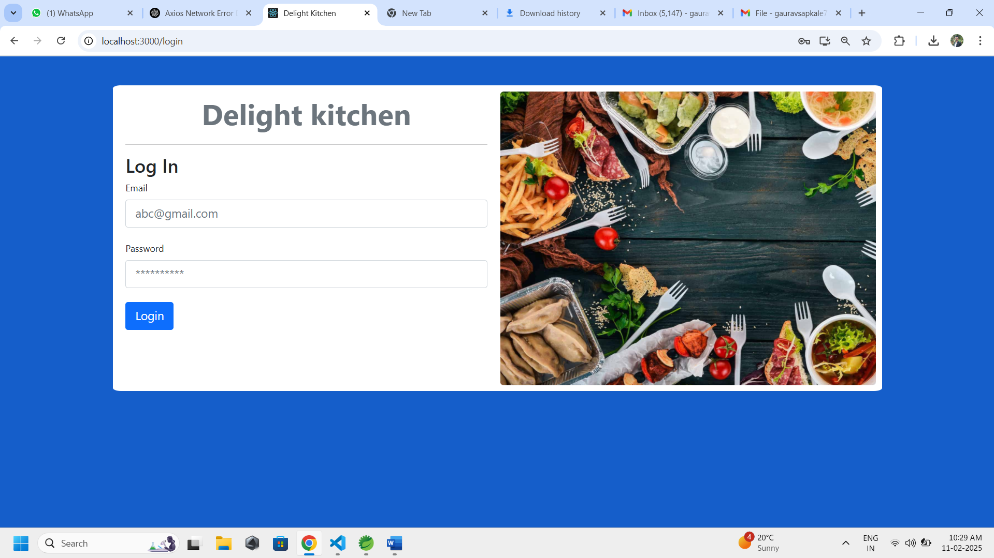

**TABLES SECTION WHERE MANAGER CAN ASSIGN TABLES TO WAITERS**

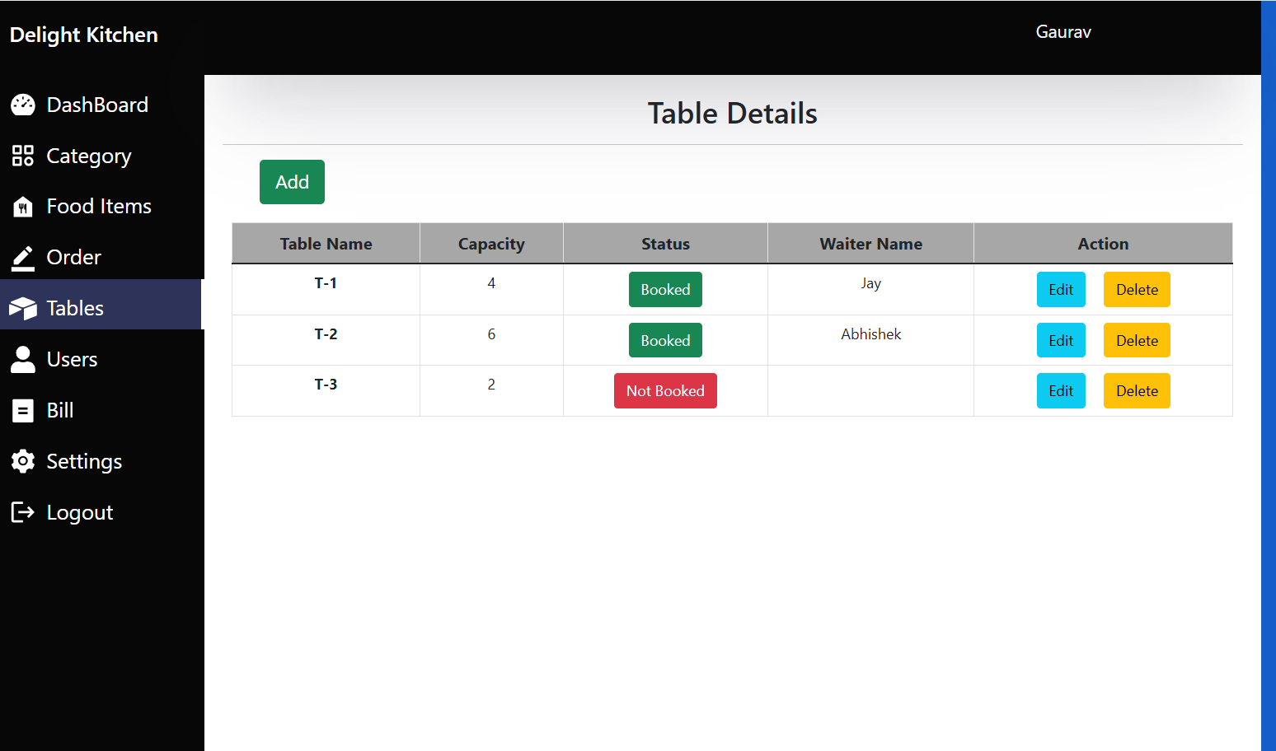

**ADDING NEW TABLES WITH CAPACITY BY MANAGER**

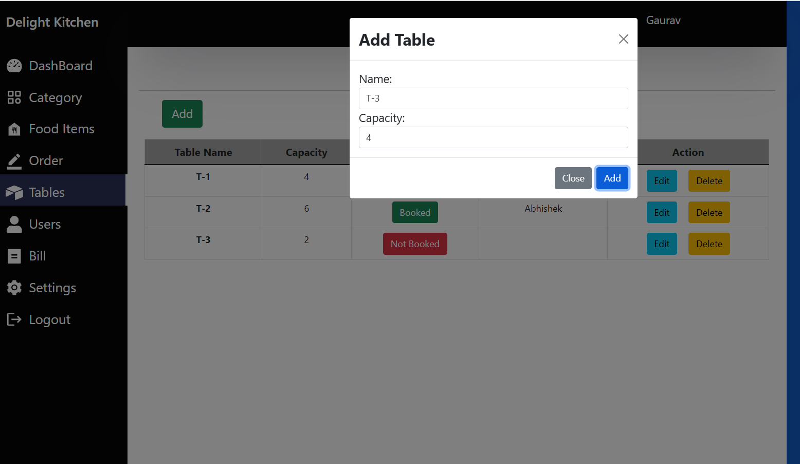

**NEW TABLE T-3 ADDED BY MANAGER which is yet to be assign to Waiter**

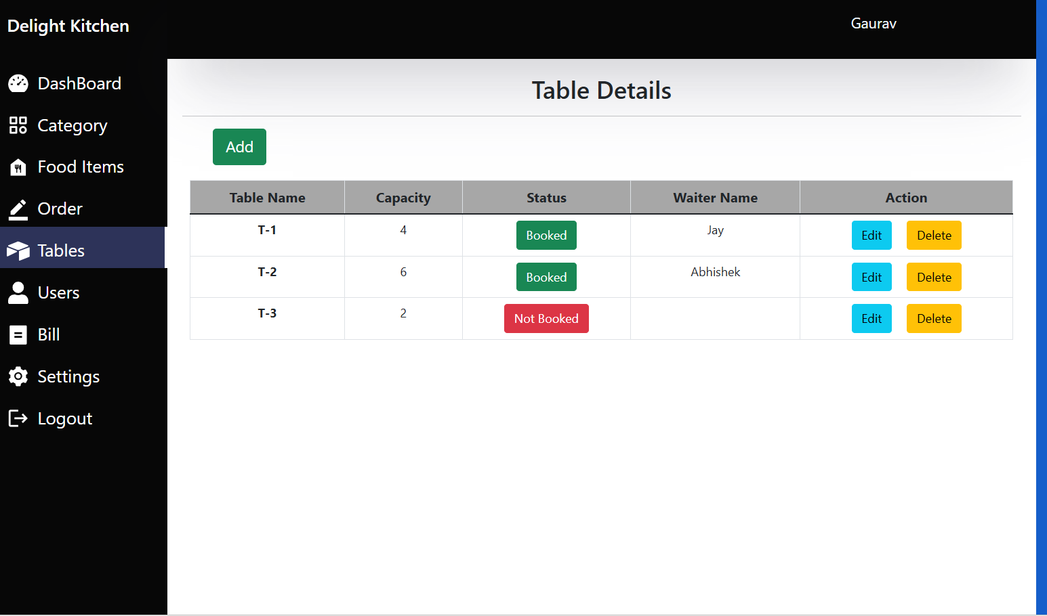

**TABLE ASSIGNED BY MANAGER TO WAITER**

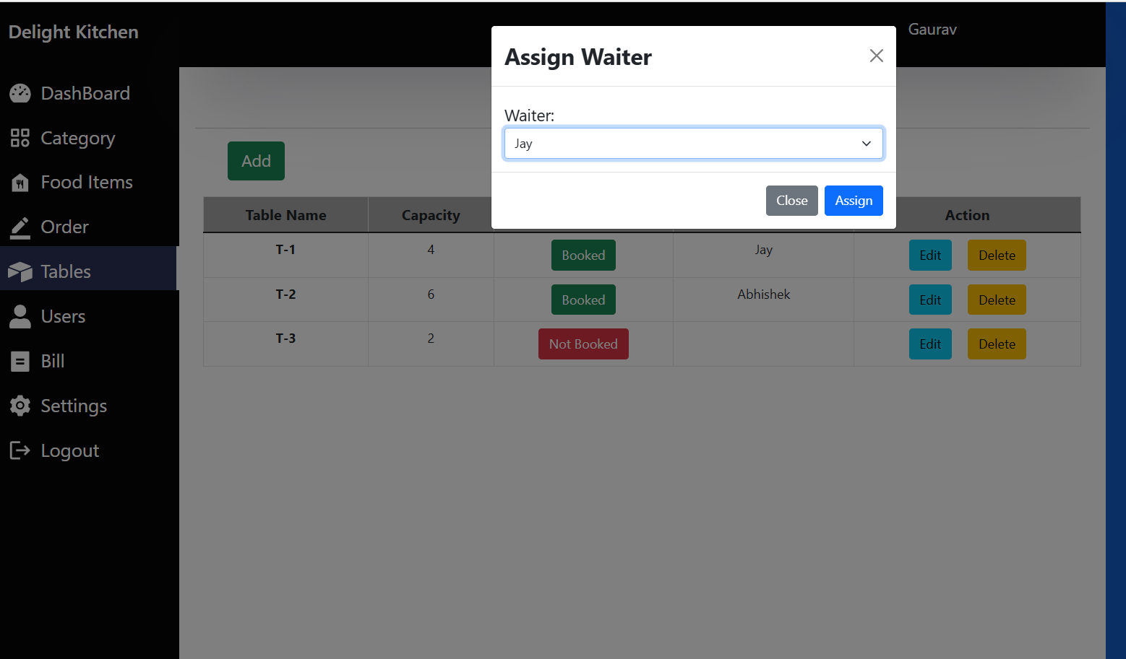

**NOW LOGIN BY WAITER**

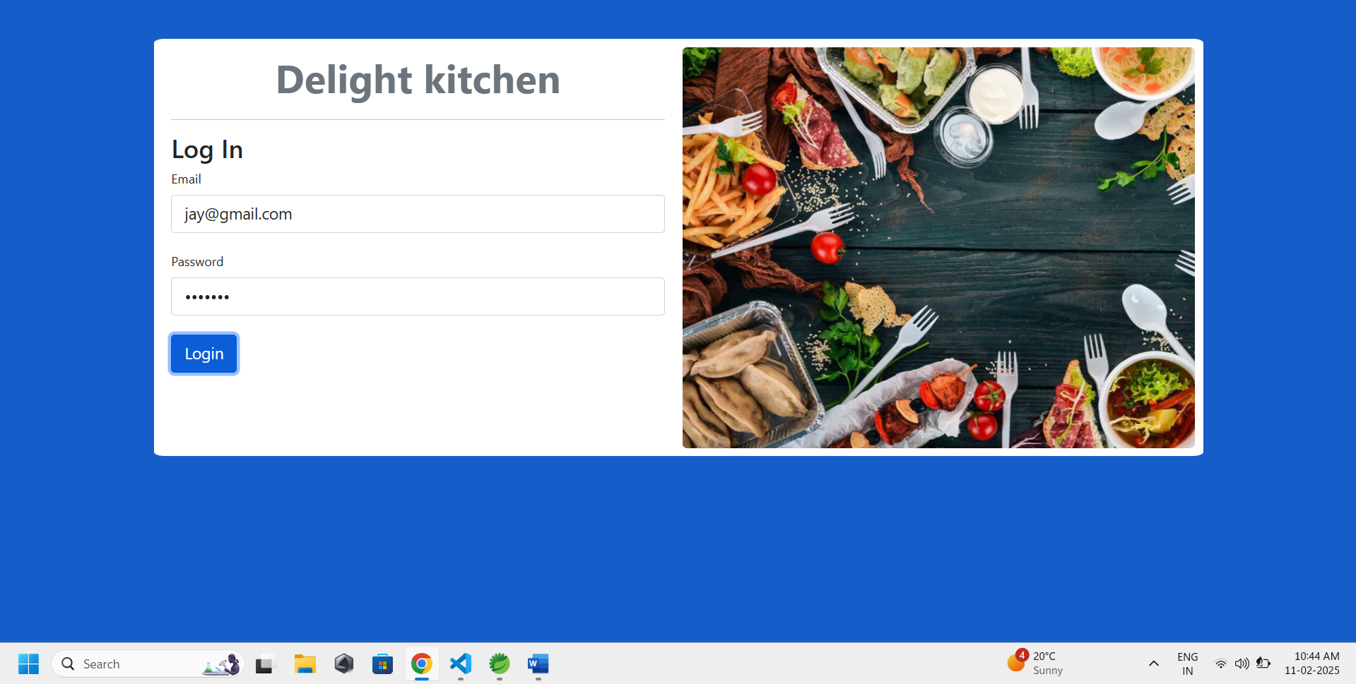

**USER INTERFACE OF WAITER**

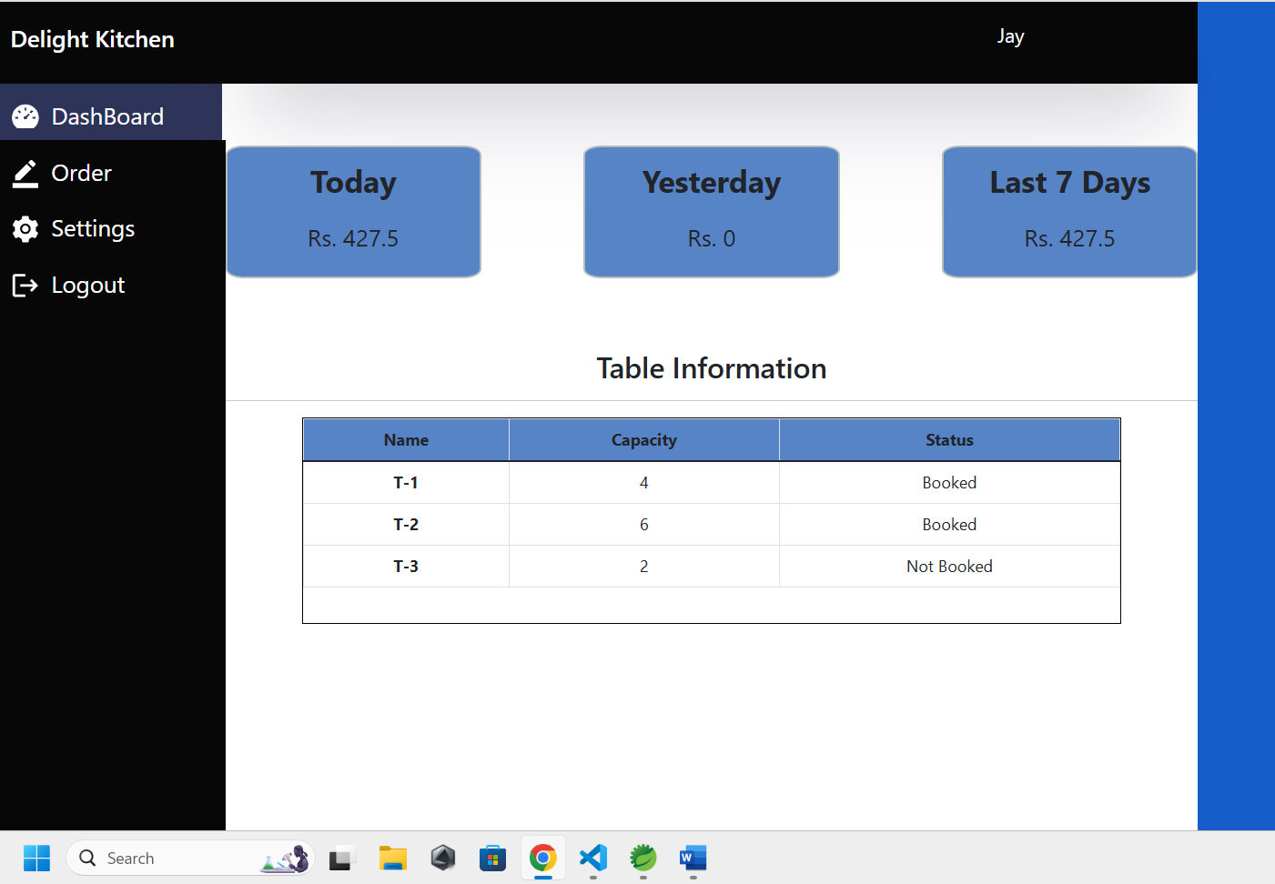

**ORDER TAKING BY WAITER OF T-9 TABLE CUSTOMERS**

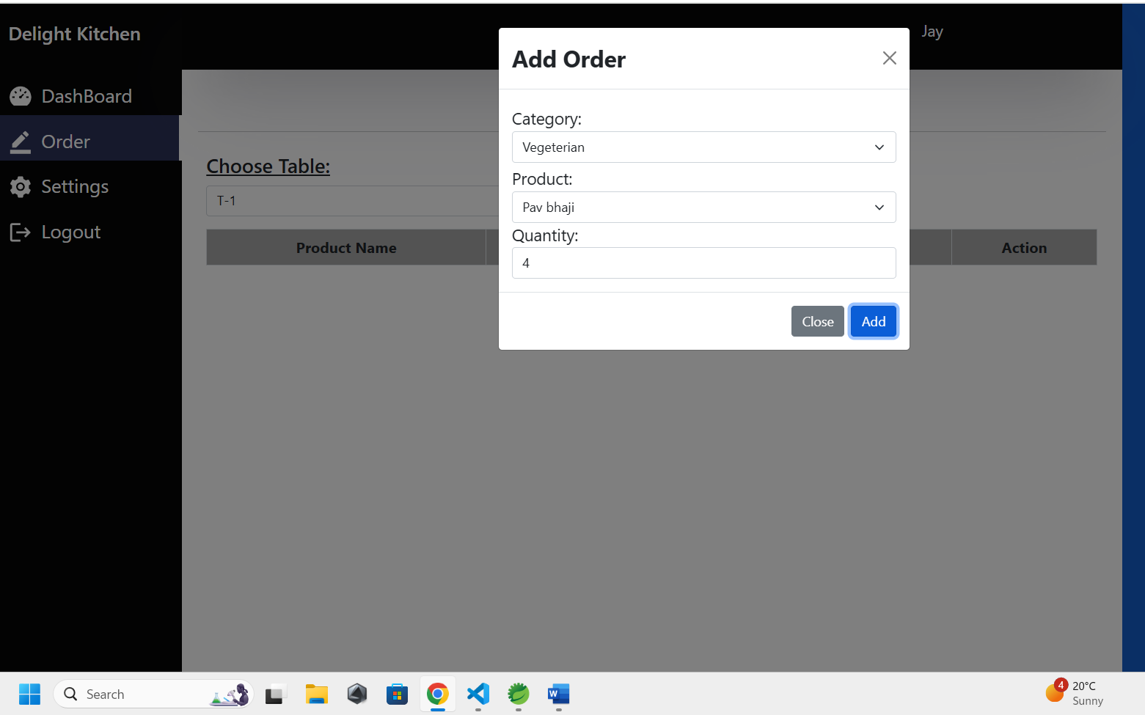

**ORDERS TAKEN BY WAITEER FROM T-9 TABLE WHICH WILL BE HANDELED BY CHEF**

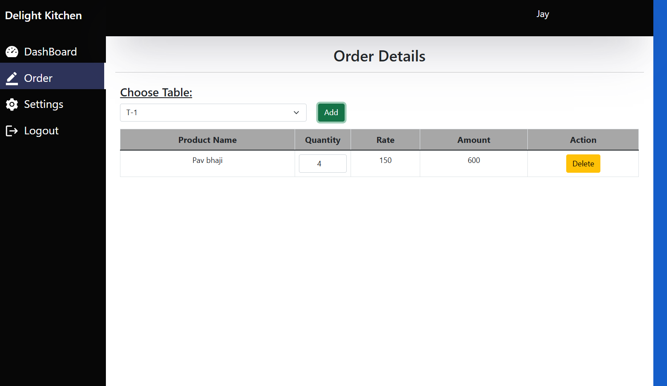

**WAITER CAN CHANGE HIS PASSWORD , NAME OR USER ID FROM SETTING SECTION**

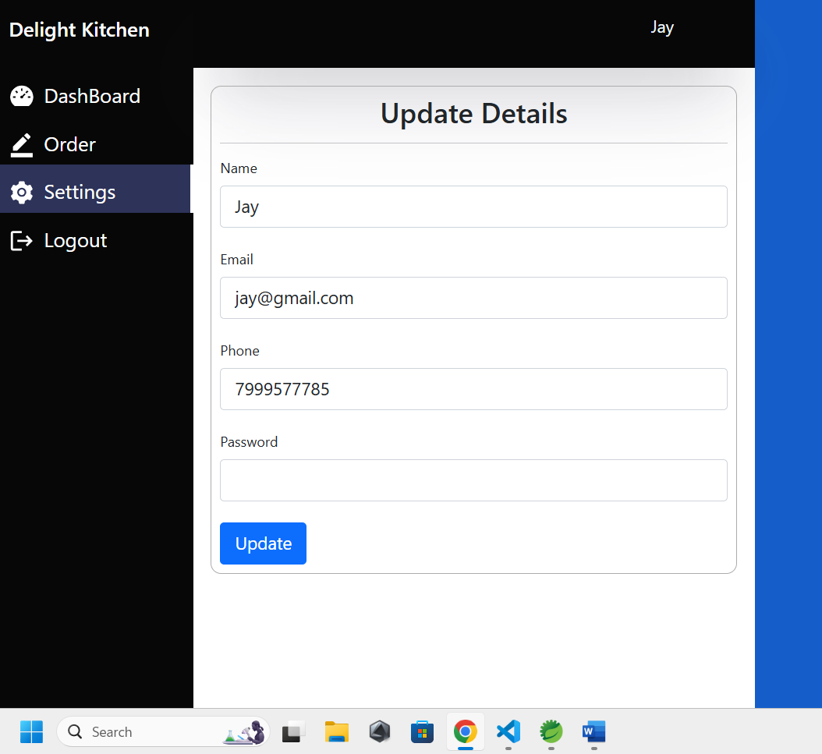

**CHEF (LATA) LOGGED IN**

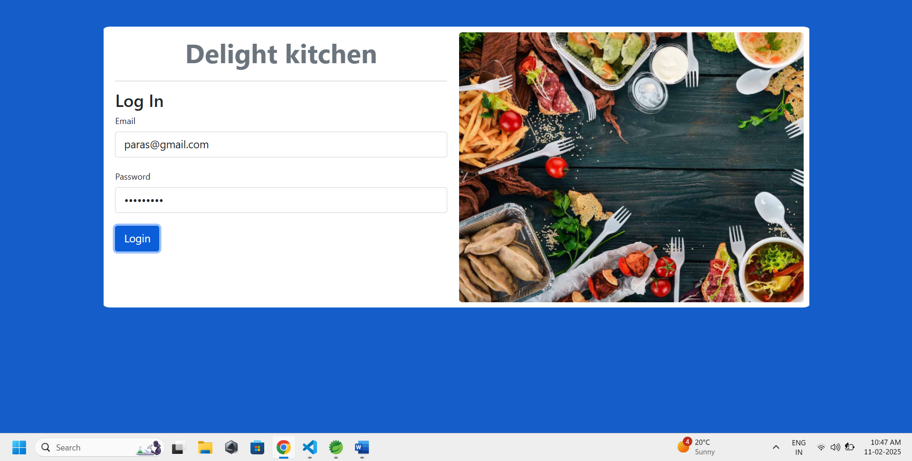

**CHEF CAN SEE PENDING ORDER LIST**

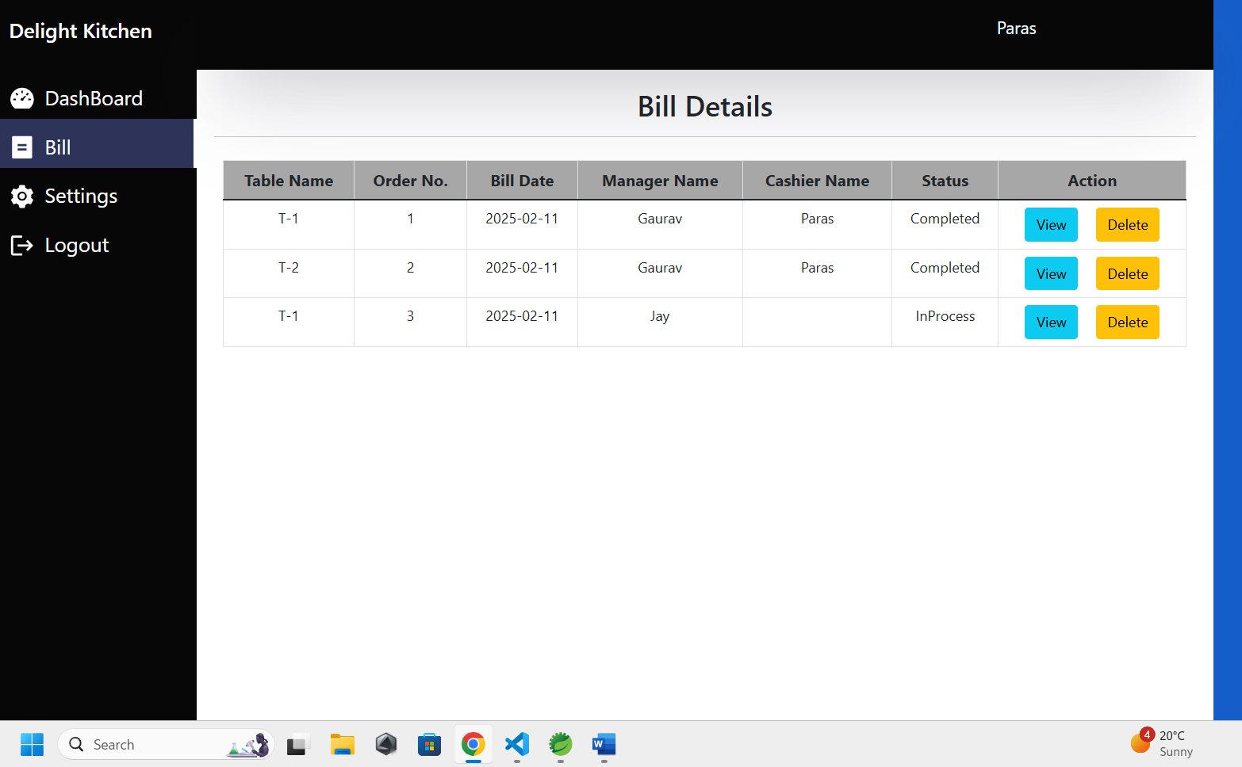

**CHEF CAN MANAGE APPROVE/ COMPLETE ORDER**

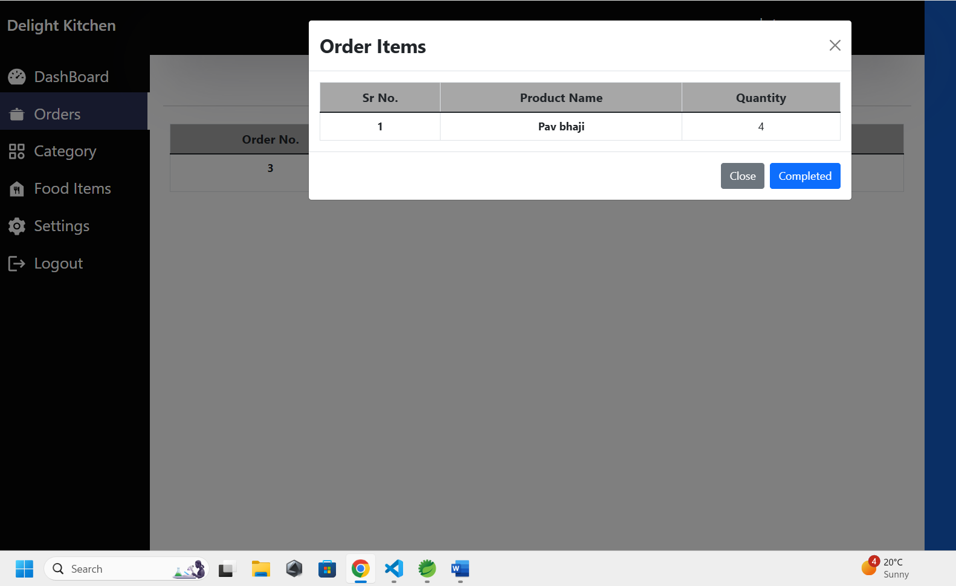

**CHEF CAN ADD/DELETE/DISABLE/ENABLE /EDIT FOOD CATEGORIES**

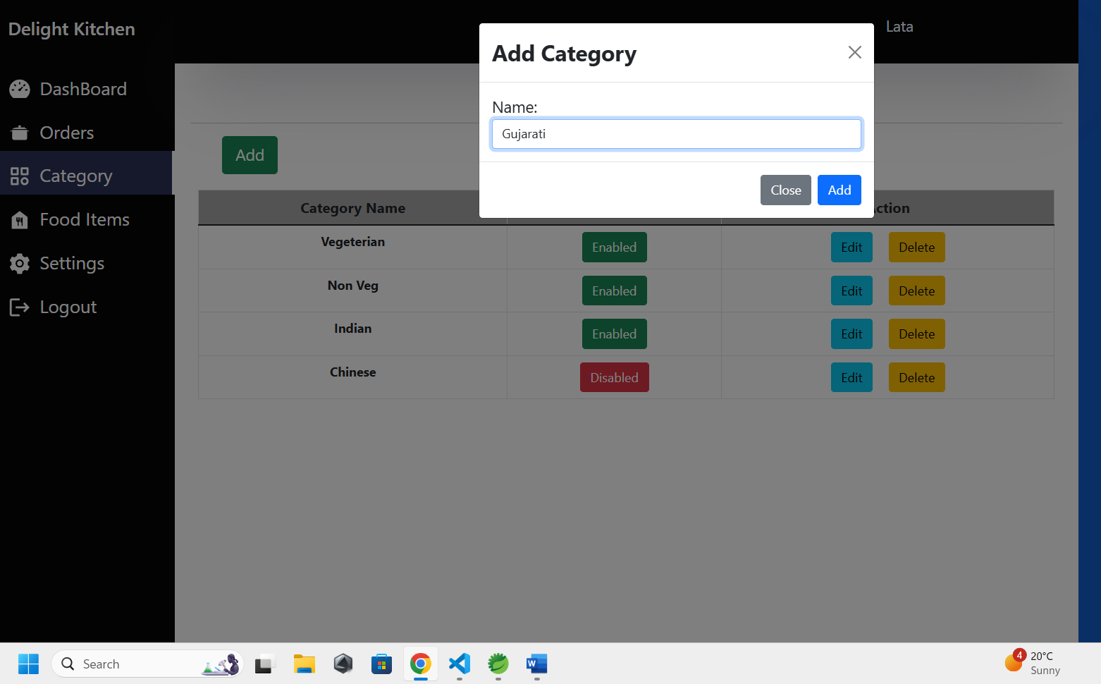

**CHEF CAN ADD/DELETE FOOD Items**

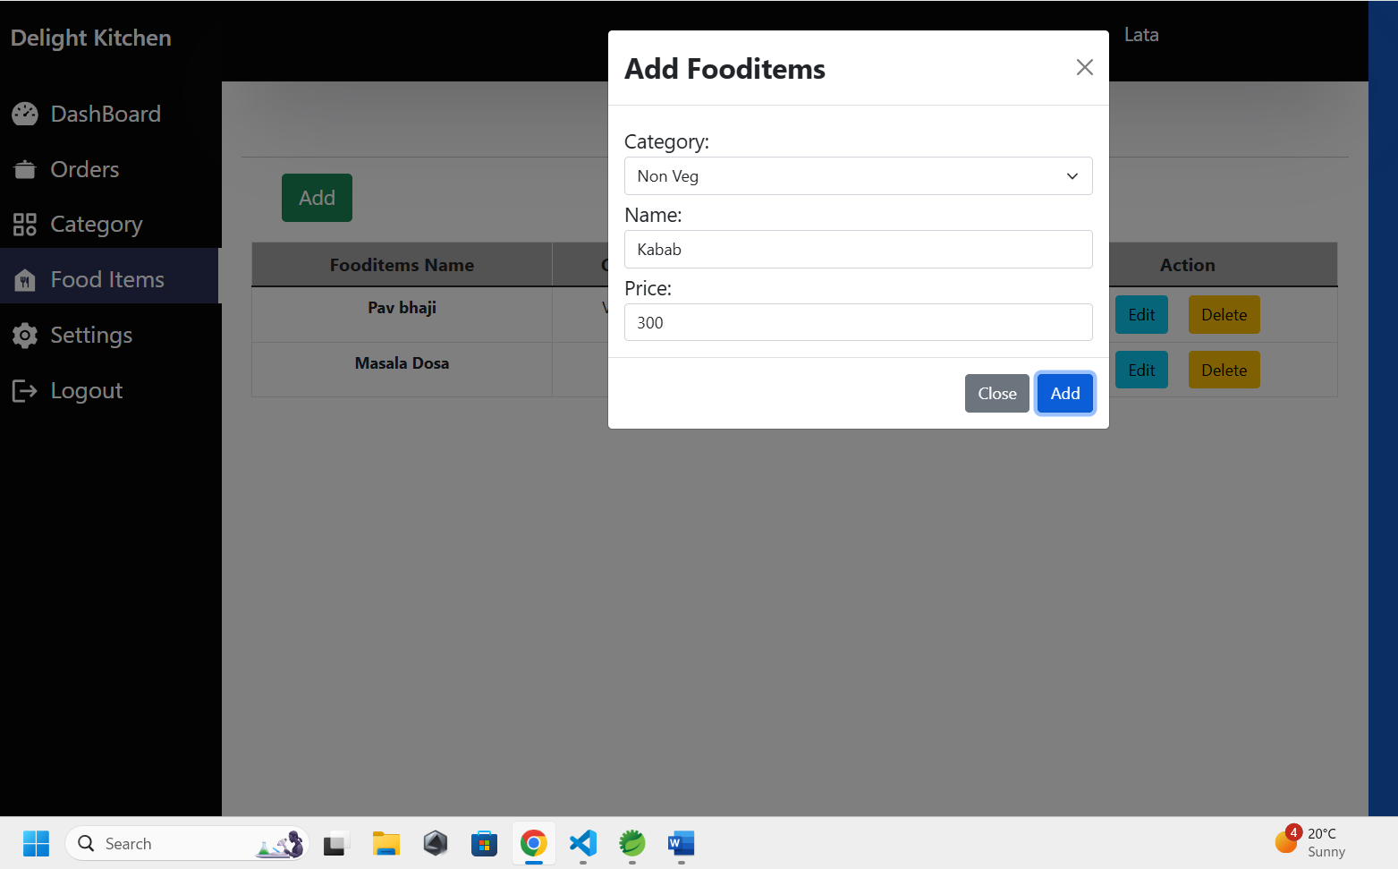

**PARAS LOG IN AS A CASHIER USING CREDIENTIAL**

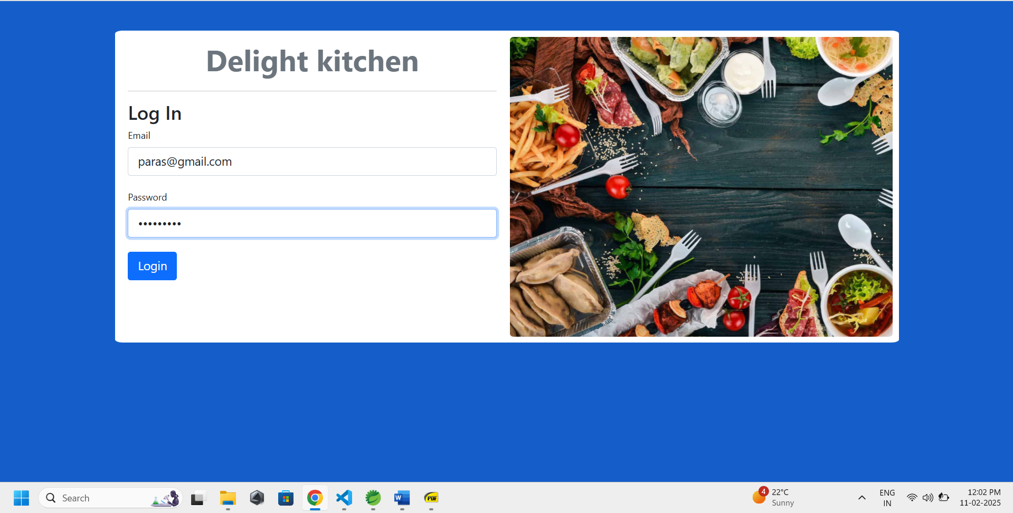

**DASHBOARD OF CASHIER**

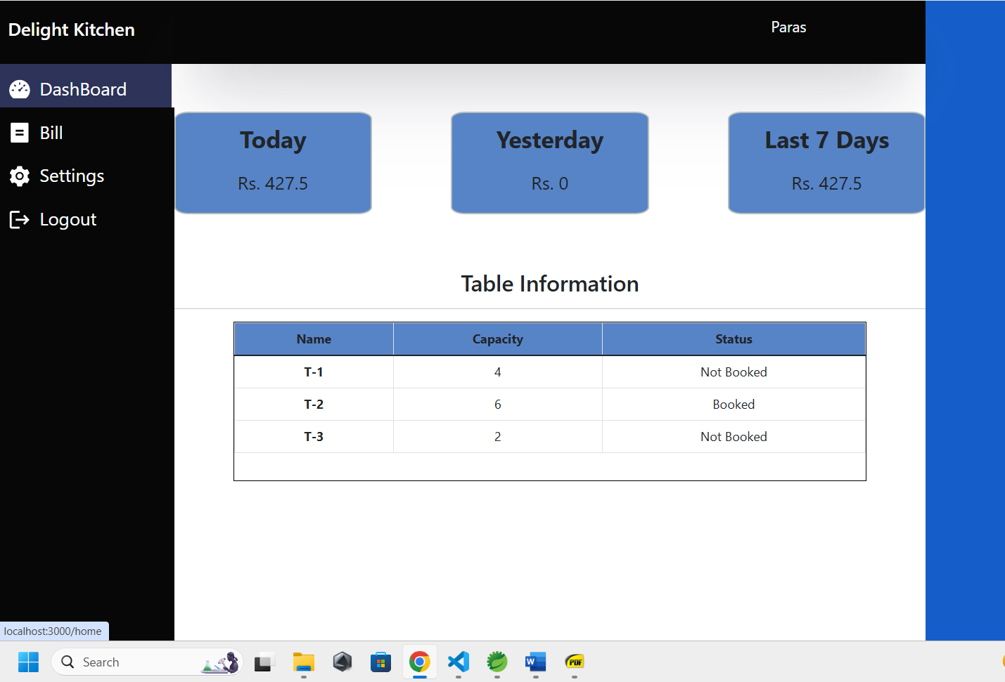

**CAHIER CAN VIEW COMPLETED AND PENDING PAYMENT BILLS**

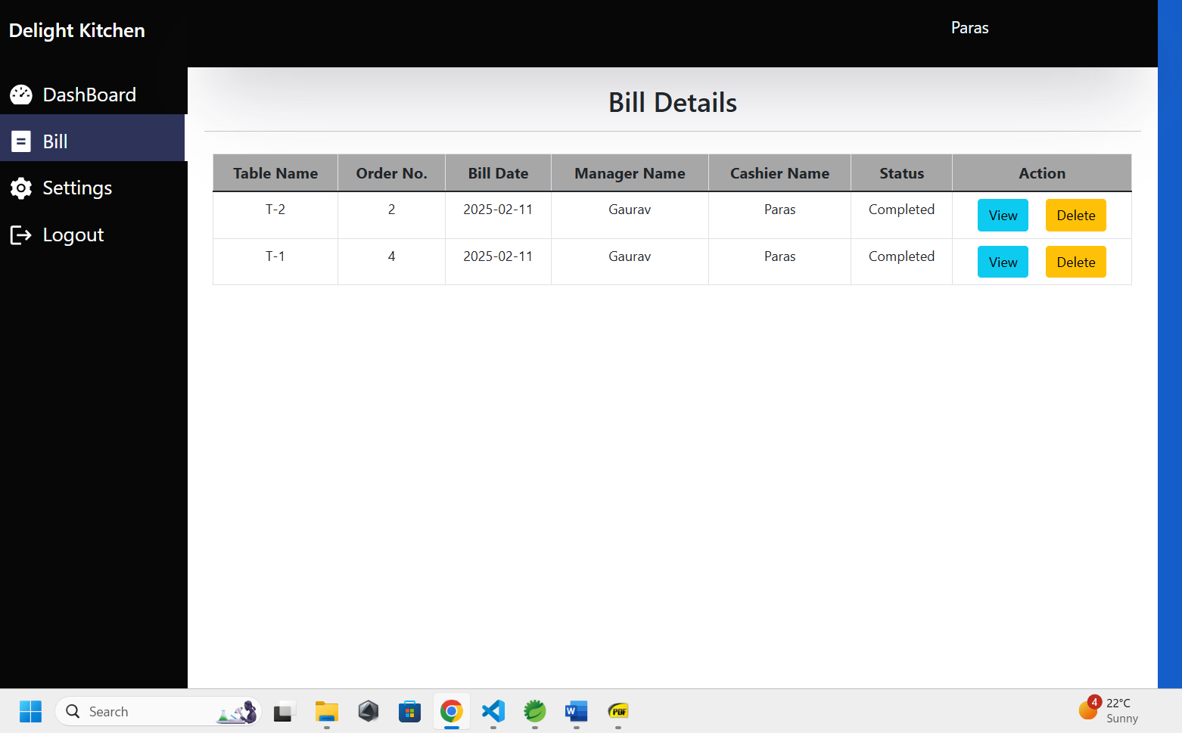

**CAHIER CAN GENERATE BILLS WITH APPLY DISCOUNTS (if needed) AND TAXES**

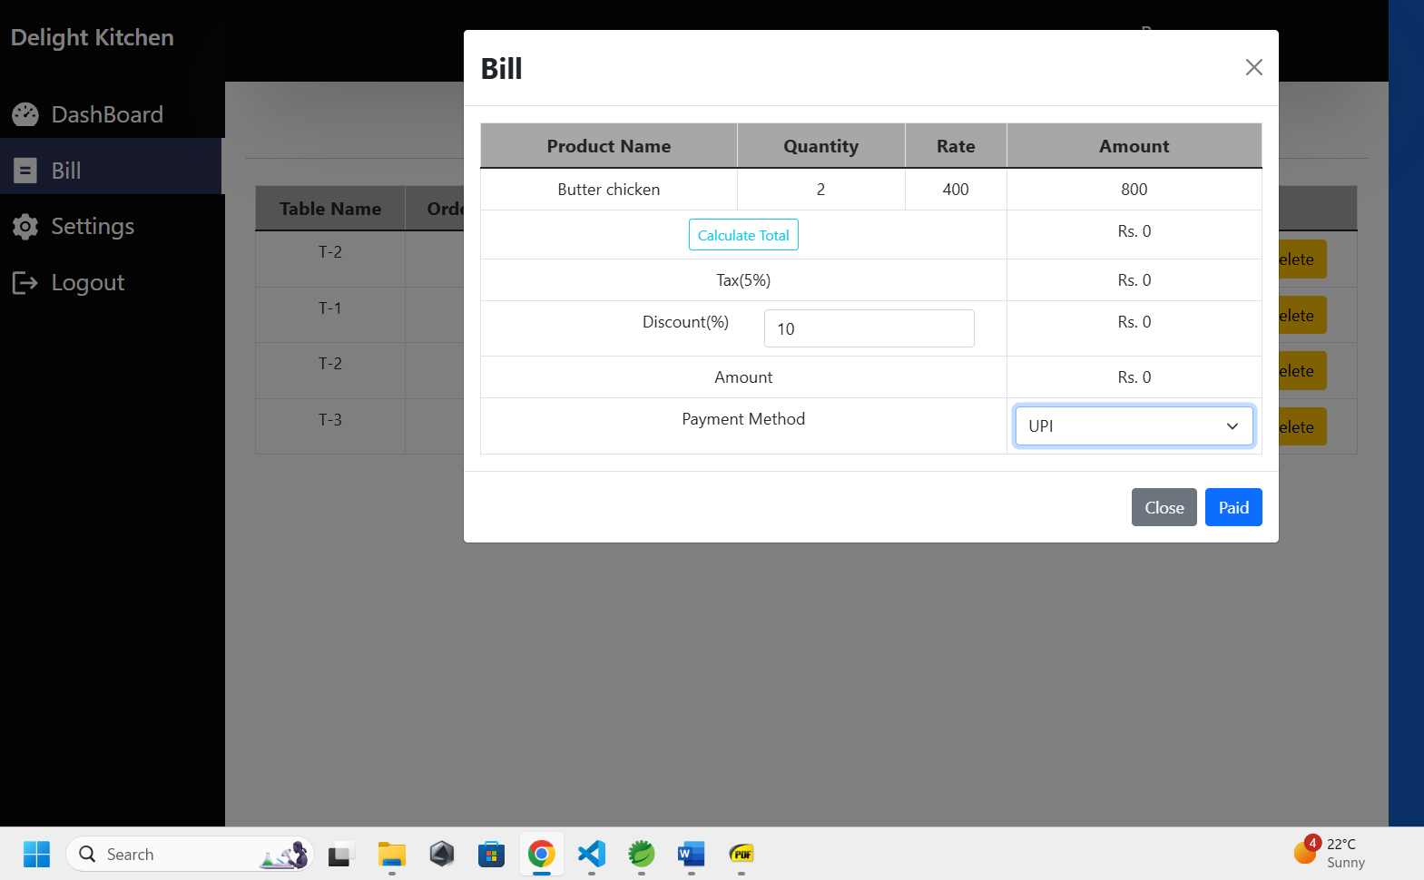

**PAYMENT DONE AFTER ORDER IS COMPLETED**

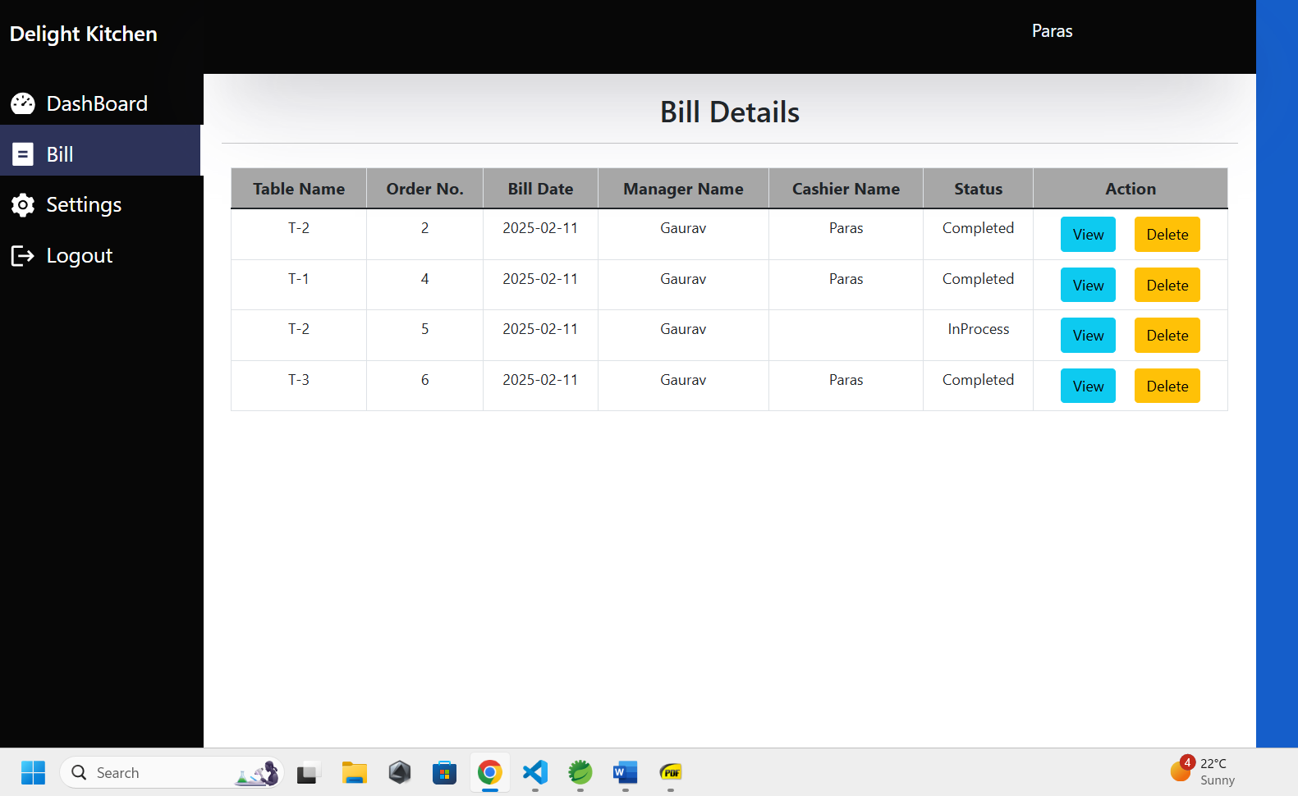

**PAYMENT REFLECTED IN DASHBOARD AFTER PAYMENT IS DONE & DASHBOARD SHOWS TODAYS ALL ORDERS IN RS**

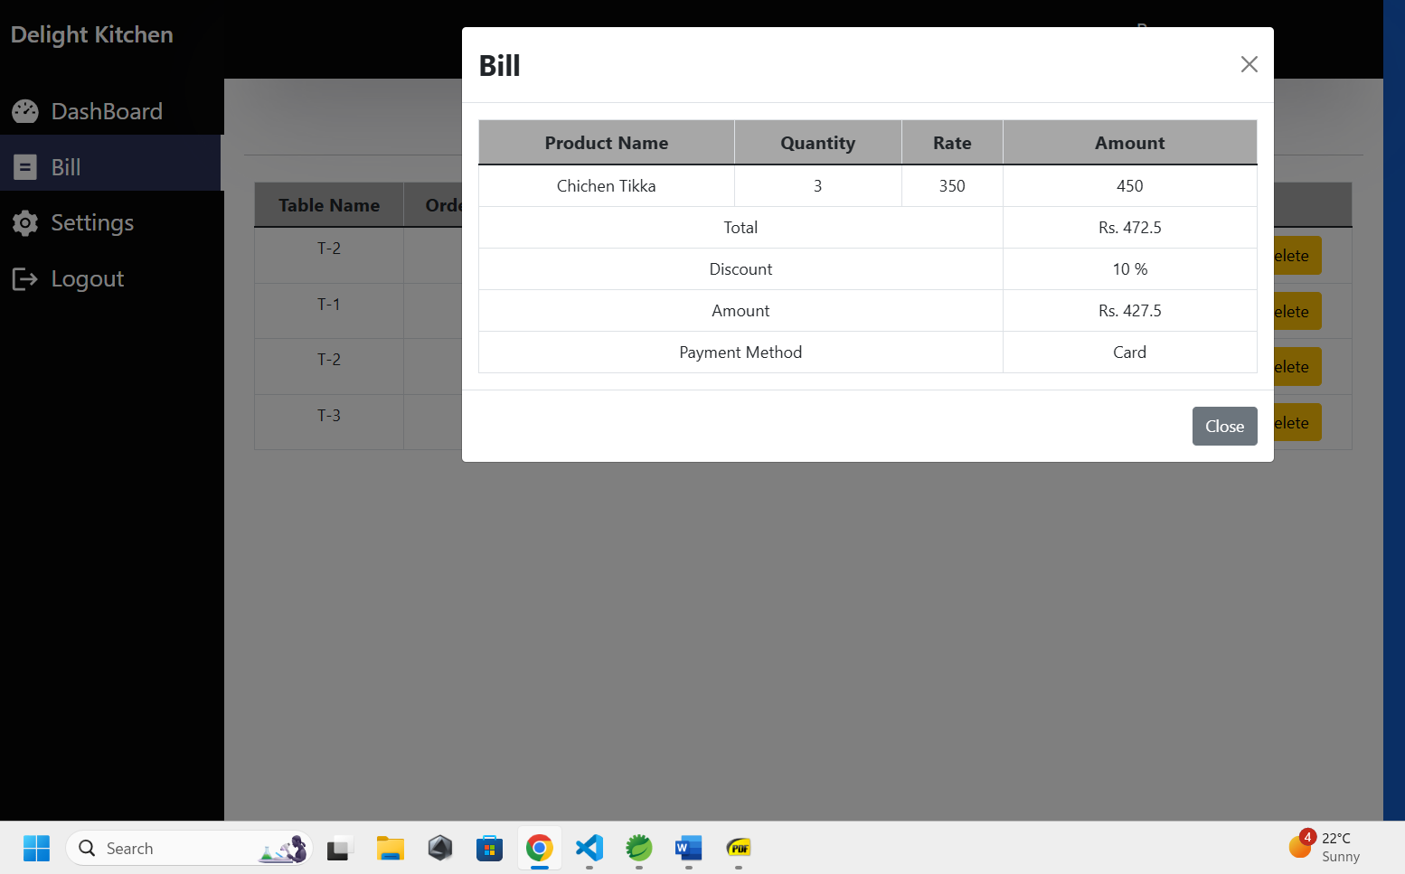

**6. Conclusion**

Restaurant System puts forth the actual working of a restaurant. Staff management, food item and category management, bill management, order management, table management, etc. similar to a restaurant are the key features of our project. Staff person having their job can access different functionalities of the application to service the visited customer effectively and additionally manager can there to monitor the workflow of the whole restaurant.

**Future Scope**

The adoption of Restaurant Management Systems (RMS) in rural and suburban areas has a promising future, driven by digital transformation and growing demand for automation. Many restaurants in these regions still rely on manual processes, and RMS can help streamline billing, order management, and inventory tracking, reducing errors and increasing efficiency. With the expansion of food delivery services, an integrated RMS can enable online ordering and delivery tracking, helping local restaurants reach more customers. Digital payments via UPI, mobile wallets, and card transactions will further boost financial inclusion. Additionally, AI-driven analytics can optimize menus, predict demand, and reduce food wastage. RMS with multi-language support and voice assistance will enhance accessibility for semi-literate users. Cloud-based mobile POS systems allow restaurant owners to monitor operations remotely. Government initiatives under Digital India can provide subsidies to promote digital adoption in rural restaurants.

Sustainable farm-to-table models can also benefit from RMS by improving supplier management and food traceability. Loyalty programs, SMS-based promotions, and WhatsApp integration will help retain customers. Overall, the future of RMS in these areas is bright, offering enhanced efficiency, better customer engagement, and higher profitability.

**7. References**

❖ JavaScript Enlightenment, Cody Lindley-First Edition, based on

JavaScript 1.5, ECMA-262, Edition

❖ Mc Graw Hill’s, Java: The complete reference 7thEdition,

Herbert Scheldt.

❖ Complete CSS Guide, Maxine Sherrin and John Allsopp- O’Reilly Media;

September 2012

**ONLINE REFERENCE**

❖ IEEE recommended practices for SRS. ANSI / IEEE Std 830 – 1993.

❖ https://www.geeksforgeeks.org/levels-in-data-flow-diagrams-dfd/

❖ www.javatpoint.com/

❖ https://www.w3schools.com/:- online tutorials website.